**A**

**Minor Project Report**

**on**

**E-Post Office System**

Submitted in

Partial fulfilment of Bachelor of Technology

in Information Technology

under Rajasthan Technical University

**

Academic Session 2015-16

**Submitted to:** **Submitted by:**

Mr. Mukesh Gupta Aanchal Mittal(12ESKIT001)

(Sr. Lecturer-IT Dept) Anamika Gupta(12ESKIT014)

Ayushi Jain (12ESKIT023)

**Under Guidance of:**  Bharti Aggarwal(12ESKIT025)

Mrs. Neha Janu

**DEPARTMENT OF INFORMATION TECHNOLOGY**

Swami Keshvanand Institute of Technology, Management & Gramothan Jaipur-302017

Rajasthan Technical University, Kota

**CERTIFICATE**

I hereby declare that the work, which is being presented in the Minor Project Report, entitled **“E-Post Office System”** in partial fulfilment for the award of Degree of Bachelor of Technology in Department of Information Technology submitted to the Swami Keshvanand Institute of Technology, Management & Gramothan, Jaipur, Rajasthan Technical University is a record of my own investigations carried under the Guidance of Mrs. Neha Kapur, Sr. Lecturer, Department of Computer Science/Information technology, Swami Keshvanand Institute of Technology, Management & Gramothan, Jaipur.

I have not submitted the matter presented in this report elsewhere for the award of any other degree.

Aanchal Mittal(12ESKIT001)

Anamika Gupta(12ESKIT014)

Ayushi Jain(12ESKIT023)

Bharti Aggarwal(12ESKIT025)

B.Tech. (Information Technology)

Swami Keshvanand Institute of Technology, Management & Gramothan, Jaipur

**Counter Signed by**

Mr. Mukesh Gupta

..................................

**Mrs. Neha Janu**

Reader

Department of Information Technology

Swami Keshvanand Institute of Technology, Management & Gramothan, Jaipur

**ACKNOWLEDGMENT**

I feel immense pleasure in expressing my regards to the Chairman **Mr. Surja Ram Meel,** Director **Mr. Jaipal Meel,** Registrar **Mrs. Rachana Meel,** Director (Academics) **Prof.** (**Dr.) S. L. Surana,** Principal & Director (D&W) **Prof. (Dr.) S. K. Calla,** Principal Prof. (Dr.) **Ramesh Pachar** Swami Keshvanand Institute of Technology, Management & Gramothan, Jaipur for providing me necessary facilities during the various stages of this work.

I would like to thank **Dr. Anil Choudhary,** HOD, Department of Information Technology and **Mrs. Neha Janu**, Reader, Department of Information Technology for provide me opportunity to work in consistent direction and providing their valuable suggestions to improve project work.

I would like to thank my esteemed guide **Mr. Mukesh Gupta**, Sr. Lecturer, Department of Computer Science/Information Technology, Swami Keshvanand Institute of Technology, Management & Gramothan, Jaipur for his valuable guidance, keen interest, constant encouragement, incessant inspiration and continuous help throughout this work. Especially I acknowledge his support when I was stuck and he was suggesting me new ideas to solve the problems. His vast experience and realistic approach have been of great help to me.

I would also like to express my thanks to my parents for their support and blessings. In addition, a very special thanks to all my colleagues and friends for their support in the completion of this work.

**Aanchal Mittal(12ESKIT001)**

**Anamika Gupta(12ESKIT014)**

**Ayushi Jain(12ESKIT023)**

**Bharti Aggarwal(12ESKIT025)**

B. Tech. (Information Technology)

Swami Keshvanand Institute of Technology, Management & Gramothan, Jaipur

**Aanchal Mittal**

**Anamika Gupta Mr. Mukesh Gupta**

**Ayushi Jain**

**Bharti Aggarwal**

B. Tech. (Information Technology)

Swami Keshvanand Institute of Technology, Management & Gramothan, Jaipur

**ABSTRACT**

The e-Post Office is the shopping portal of the world-renowned postal service on the Internet and an additional distribution channel. It sells Stamps, Postcards, Packets, and Cartons and has services like courier, registering for electricity vendors, selling mobile cards, etc. Under this website many products and services can be ordered, that are also available in a "normal" branch. The product prices are identical with the prices of their normal branches.

The e-Post Office is expanded permanently through new products and services in order to offer a product portfolio corresponding to the market. Private customer and business customers can order the selected products of the postal service online quickly and comfortably.

Target groups of customer of the e-Post Office are predominantly little and middle-class business. The customers can have a payment alternative through credit card. In order to use the load writing procedure, the customer registers itself in the e-Post Office and receives a login for its purchases name. You have to develop this website, which captures the above functionality. It is an Internet application.

**Users of the system:** Customer is the user of the system. An administrator of the website is the super user. When the user types in the URL of the website, a Welcome page is shown which has a menu on the left hand side, a banner at the top and any related links to other sites. This site contains an online catalogue for the user. User has to login to Welcome Page before ordering anything. Login functionality should check the authenticity of the user from the database.

**CONTENTS**

**CERTIFICATE... ... ... ... ... ... ... ... ……………………………………………………... i**

**ACKNOWLEDGMENT………………………………………………………... ... ... ... . ii**

**ABSTRACT………………………………………………………... ... ... ... ... ... ... ... ... . iii**

**CONTENTS………………………………………………………... ... ... ... ... ... ... ... ... . iv**

**1. INTRODUCTION………………………………………………………………………1**

1.1. Purpose

1.2. Scope

1.3. Definitions, Acronyms and Abbreviations.

1.4. Technologies Used

**2. OVERALL DESCRIPTION……………….......……………………………………… 5**

**3. DESIGN PROCESS... ... ... ... ... ... ... ... ... ... ……………………...……………... ... .. 8**

**4. UML DIAGRAM……………………...……………………………………………….. 10**

**5. DATABASE DESIGN……………………………………………….... ………….... ... 13**

**6. UI DESIGN COMPONENT... ... ... ... ... ... ... ... ... ... ... ... ... ... ... ... ... ... ... ... ... ... ... 17**

**7. SUPPLEMENTARY REQUIREMENTS…………………………………………..…25**

**7.1. Software Requirement**

**7.2. Hardware Requirement**

8. **REFERENCES…………………………………………...……………………………..26**

Chapter- 1

**INTRODUCTION**

The e-Post Office is the shopping portal of the world-renowned postal service on the Internet and an additional distribution channel. It sells Stamps, Postcards, Packets, and Cartons and has services like courier, registering for electricity vendors, selling mobile cards, etc. Under this website many products and services can be ordered, that are also available in a "normal" branch. The product prices are identical with the prices of their normal branches.

The e-Post Office is expanded permanently through new products and services in order to offer a product portfolio corresponding to the market. Private customer and business customers can order the selected products of the postal service online quickly and comfortably. Besides this, the e-Services offer new flexibility through e-Packet, the PICKUP order for packages over the Internet as well as the online forwarding order and storage order. For the case of the absence or the move, one can let delegate here the after shipment of the postal service at another address or store the letter shipments. The customers can register themselves and can be served individually.

Target groups of customer of the e-Post Office are predominantly little and middle-class business. The customers can have a payment alternative through credit card. In order to use the load writing procedure, the customer registers itself in the e-Post Office and receives a login for its purchases name. You have to develop this website, which captures the above functionality. It is an Internet application.

**1.1. Purpose:**

The Post Office needs to sell Stamps, Postcards & Envelopes to customer living in any part of the world. The website will show all products in categorized manner. Customer can browse any product for its price and other details and can order the product. Orders needs to accompany with shipping & billing details. Customer has to pay order amount online through credit cards. Products can be managed by operators from admin panel. Operator can be created by admin. Admin can keep track of orders through admin panel.

The main purpose of the system is to enable customers to browse and order from any part of the world and hence increasing business scope.

**1.2. Scope:**

In e-post office system,

1) User can log in to his/her account.

2) View the different offers.

3) Post his/her view about the offers.

4) Change password.

5) Log out his/her account.

**1.3. Definitions, Acronyms and Abbreviations:**

Various technical terms is used in this document often. Their descriptions are

as follows:-

1. Admin:- It is administrator of system. It has all rights of system.

2. MySQL:- A database management system that provides a flexible and efficient database platform to maintain records of the system.

3. UML:- It is Unified Modeling Languages a standard language for writing software blueprints. The UML may be used to visualize, specify, construct and document.

4. Eclipse:- The Eclipse IDE is developed by an open source community that focuses on developing a universal platform of frameworks and powerful tools that make it easy and cost-effective to build and deploy software and helps to design the diagrams like class, use-case, sequence diagrams.

5. HTML:- It is hyper text markup language. It is used for creation of webpages.

**1.4. Technologies Used**

**1) SQL Server:**

A database management, or DBMS, gives the user access to their data and helps them transform the data into information. Such database management systems include database, paradox, IMS, SQL Server and SQL Server. These systems allow users to create, update and extract information from their database.

* **RELATIONAL DATABASE:**

Sometimes all the information of interest to a business operation can be stored in one table. SQL Server makes it very easy to link the data in multiple tables. Matching an employee to the department in which they work is one example. This is what makes SQL Server a relational database management system, or RDBMS. It stores data in two or more tables and enables you to define relationships between the table and enables you to define relationships between the tables.

* **Advantages of RDBMS:**
* Redundancy can be avoided
* Inconsistency can be eliminated
* Data can be Shared
* Standards can be enforced
* Security restrictions can be applied
* Integrity can be maintained
* Conflicting requirements can be balanced
* Data independence can be achieved.
* **Disadvantages of RDBMS:**

A significant disadvantage of the DBMS system is cost. In addition to the cost of purchasing of developing the software.

**2) APACHE TOMCAT**:-

Web-server for running J2EE applications over network.

**3) HTML:-**

Hypertext mark up language, commonly referred to as HTML, is the standard mark up language used to create web pages. Web browsers can read HTML files and render them into visible or audible web pages. HTML describes the structure of a website semantically along with cues for presentation, making it a mark up language, rather than

a programming language. HTML elements form the building blocks of all websites. HTML allows images and objects to be embedded and can be used to create interactive forms. It provides a means to create structured documents by denoting structural semantics for text such as headings, paragraphs, lists, links, quotes and other items.

HTML can embed scripts written in languages such as JavaScript which affect the behaviour of HTML web pages. Web browsers can also refer to Cascading Style Sheets (CSS) to define the look and layout of text and other material. The World Wide Web Consortium (W3C), maintainer of both the HTML and the CSS standards, has encouraged the use of CSS over explicit presentational HTML.

**4) JAVA:-**

Java is a set of several computer software and specifications that provides a system for developing application software and deploying it in a cross-platform computing environment. Java is used in a wide variety of computing platforms from embedded devices and mobile phones to enterprise servers and supercomputers. While less common, Java applets run in secure, sandboxed environments to provide many features of native applications and can be embedded in HTML pages.

Writing in the Java programming language is the primary way to produce code that will be deployed as byte code in a Java Virtual Machine (JVM); byte code compilers are also available for other languages, including Ada, JavaScript, Python, and Ruby. In addition, several languages have been designed to run natively on the JVM, including Scala, Clojure and Groovy. Java syntax borrows heavily from C and C++, but object-oriented features are modeled after Smalltalk and Objective-C.

Chapter 2

**OVERALL DESCRIPTION**

Technology in our society becomes more complex over years through many development of a new technique that could meet the ever-increasing needs in all aspects of information.

After analyzing the requirements of the task to be performed, the next step is to analyze the problem and understand its context. The first activity in the phase is studying the existing system and other is to understand the requirements and domain of the new system. Both the activities are equally important, but the first activity serves as a basis of giving the functional specifications and then successful design of the proposed system. Understanding the properties and requirements of a new system is more difficult and requires creative thinking and understanding of existing running system is also difficult, improper understanding of present system can lead diversion from solution.

**CONCEPTUAL FRAMEWORK OF THE STUDY**

Computerization program deemed the best alternative solution to once stagnant method of manual operation. The process virtually enhances the technical capability of companies and schools in the pursuit of their business venture. This study was further conducted to be able to study the organizational structure of the company and make research on its history, function, objective, policies, system and procedure, duties and responsibilities of each personnel, to familiarized the research with the process flow of the present system, to propose an online system for the company and to develop and implement the proposal system. It includes also the Systems Development Life Cycle.

A software development life cycle (SWDLC) is an abstract representation of gradual development and evolution of the software that undergoes a series of sequential and concurrent steps of software development process.

**Software Development Life Cycle**

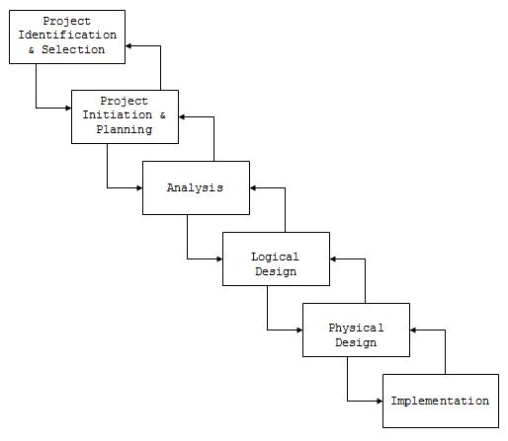

**Requirement Analysis**

This step analyses the requirements of the software. It is performed after the feasibility study has been done. The requirement term in this concern can be understood as –

* A condition or capability needed by a customer to solve a problem, and
* A condition or capability that must be met by a system, software, document, manual, report etc.

**Design**

With full and complete understanding of the requirement analyses phases the next step is the designing of the software. This step is divided into two level of designing: named as, Preliminary Design or High Level Design and Detailed Design or Low Level Design. Software Design Specification is built to have:

* Software architecture in the layered sequential layout.
* Data structures, algorithm, control structures,
* The interfaces required for the software, and
* The satisfaction that requirement have been met in the design.

**Coding**

This is the phase that produces the actual code that will be delivered to the customer as the operational product. To develop the code, a specific programming language is chosen either through its feature or directly specified by the customer

**Module Level Testing**

Individual developed modules are tested here. It is also called the unit level testing. This testing is performed for each of the module separately.

**Integration and System Testing**

All modules are connected and integrated appropriately with each other. Interfaces are provided among them, and then whole system is tested fully.

**Delivery, Implementation and Maintenance**

Once the complete system is tested then that system is delivered to the customer who will implement it on its organization site. After delivery, any modifications or changes can be made to help in maintenance.

This is the complete software development life cycle. This is the basic general process which is followed to develop this software product.

Chapter 3

**DESIGN PROCESS**

The Given Design Challenge which is stated in the starting of this document demanded that we frame a dynamic database driven website. Broadly this website should be able to portrait dynamic content on a webpage as well as give the user interactive input sessions. These challenges demanded some research which led to the following conclusion –

**3.1 What Do We Need?**

1. A server side scripting language that would process data on the request of the user.

2. An effective way of storing all the data which the website uses to output the results. In short a Database management System.

3. A query language to effectively retrieve, alter and add to the stored data in our database.

4. An interface to represent the output of the scripting language in the form of html.

5. A web server which is needed to host the website and to do all the computations needed to portrait the generated data on the basis of input received from the user.

**3.2 Available Choices:**

1) **.**NET Framework**-** The .NET Framework is a new computing platform that simplifies application development in the highly distributed environment of the Internet.

2) PHP -It is a scripting language designed to produce dynamic web pages. It is widely used and can be embedded into html.

3) JSP (Java Server Pages)(which is used)-is a java technology that facilitates software developers to dynamically generate html, xml and other kind of documents. It is also a platform independent technology.

4) PERL with CGI Scripts - Perl is a high level scripting language which borrows its features from C shell scripting etc. It can be used to do CGI (Common Gateway Interface) programming on a web server. It denies a way to pass the request and arguments to the command line and to return the results.

**Database Design:**

1. MYSQL (which we used)-It is a relational database management system which is popular for web applications.

2. MSSQL-It is also a database management system developed by Microsoft. It also has issues with platform independency.

**3.3 Choice made:**

1. JSP is a java technology that facilitates software developers to dynamically generate html, xml. It is also a platform independent technology.

2. MYSQL as the relational database management system and SQL as our query language.

**3.4 Arguments leading to our choice:**

1. JSP is a java technology that facilitates software developers to dynamically generate html, xml and other kind of documents. It is also a platform independent technology.

2. MYSQL became a choice as it is too a platform independent software and works very well with JSP.

Chapter – 4

**UML DIAGRAM**

**3.1. Use Case Diagram:**

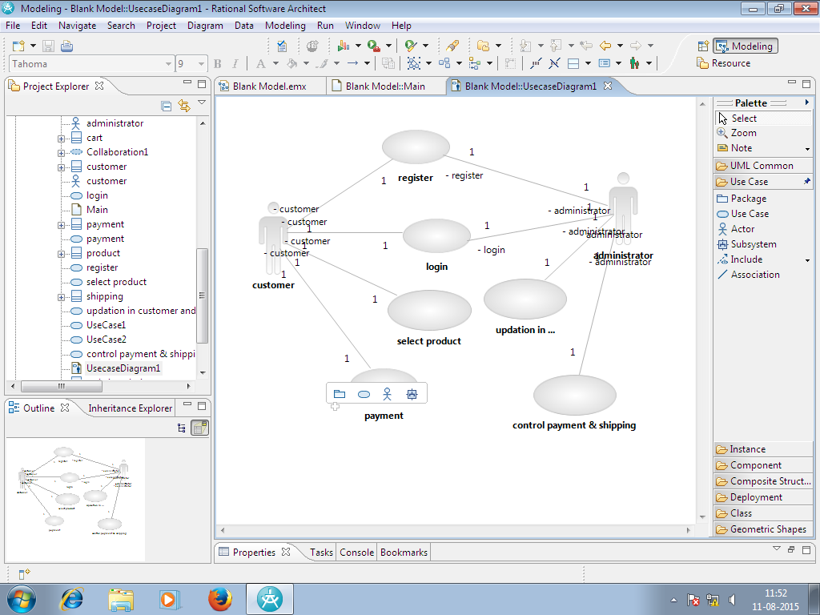

Fig 1- usecase diagram of e-post office system

**3.2. Class Diagram:**

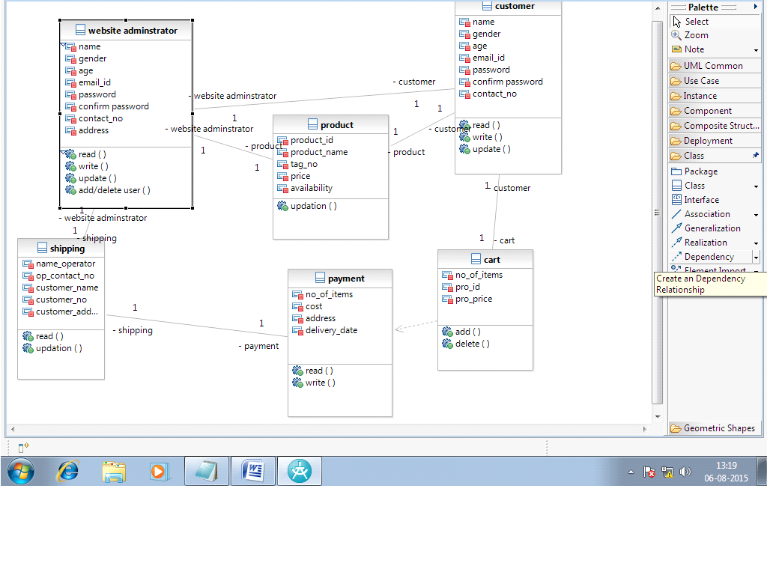 Fig 2- class diagram of e-post office system

**3.3. Sequence Diagram:**

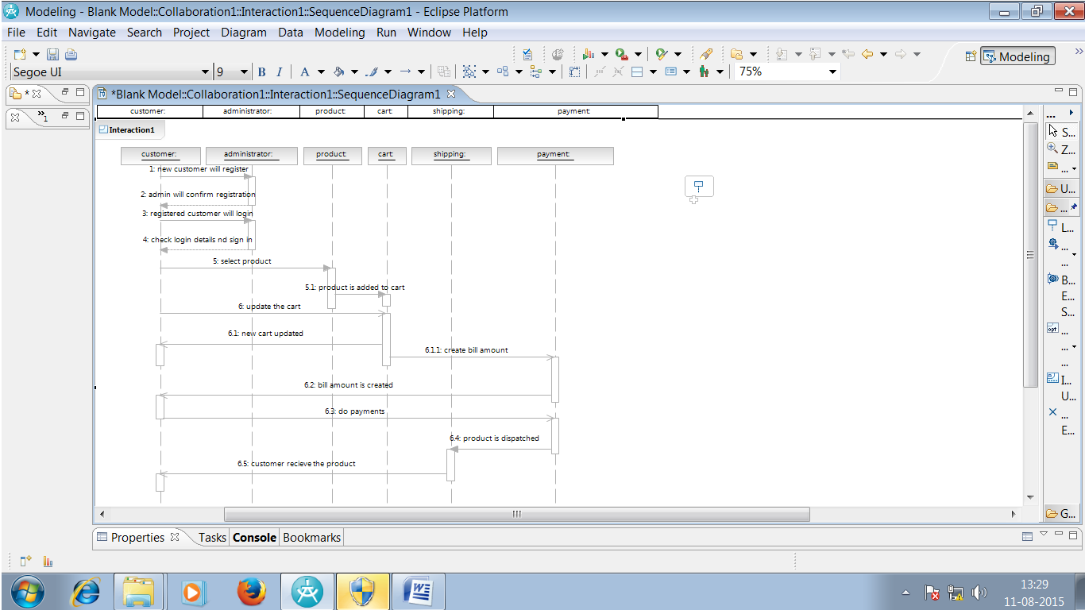

Fig 3- sequence diagram of e-post office system

Chapter – 5

**DATABASE DESIGN**

The database of the project was designed using MySQL. The following were the tables created for storing the data:

1. admin

2. registration

3. products

4. cart

5. delivery

**E-Post Office System Database Tables:-**

Screenshots are:

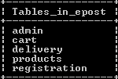

Snap 1

Above snapshot represents the tables present in the database (epost).

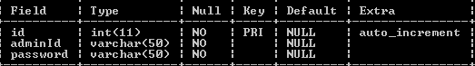

Snap 2

Above snapshot is the description of the “admin” table.

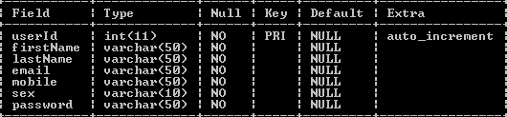

Snap 3

Above snapshot is the description of the “registration” table.

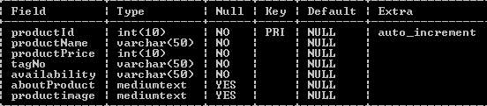

Snap 4

Above snapshot is the description of the “product” table.

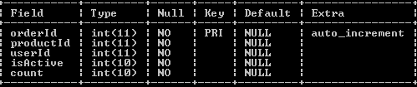

Snap 5

Above snapshot is the description of the “cart” table.

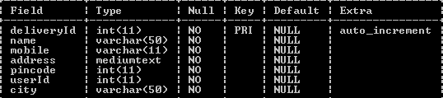

Snap 6

Above snapshot is the description of the “delivery” table.

Screenshot (63).png

Snap 7

Above snapshot show the data of the “admin” table.

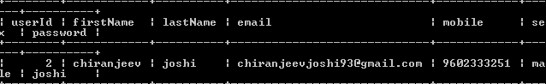

Snap 8

Above snapshot show the data of the “registration” table.

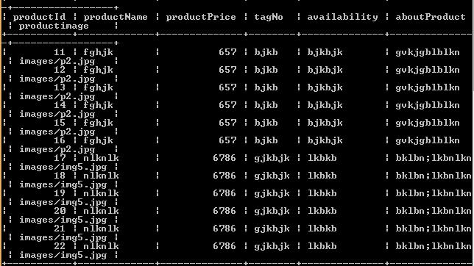

Snap 9

Above snapshot show the data of the “product” table.

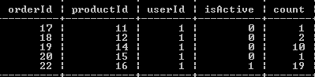

Snap 10

Above snapshot show the data of the “cart” table.

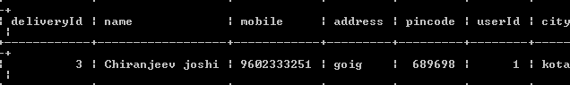

Snap 11

Above snapshot show the data of the “delivery” table.

Chapter - 6

**UI DESIGN COMPONENT**

A) User Module:-

1) Front Page:

The front page of project e-post examination system.

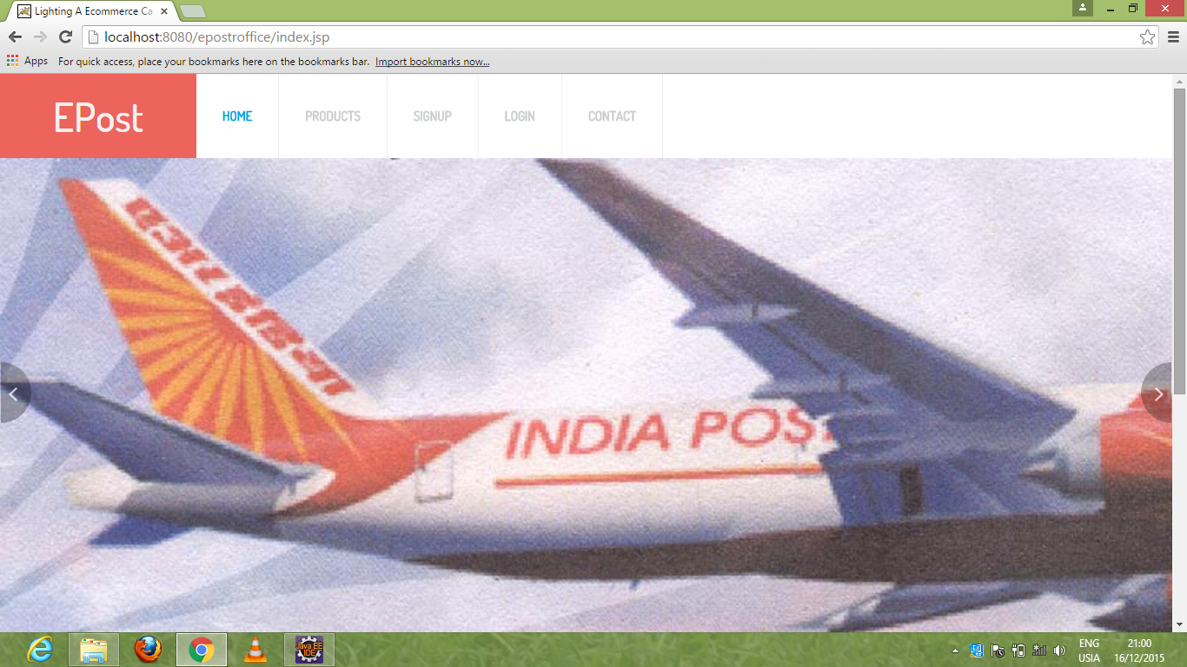

Snap 6.1 Front Page

2) Registration Page-

In this, customer can register through this page by filling the entries. The field are first name,last name, email address,mobile,password.

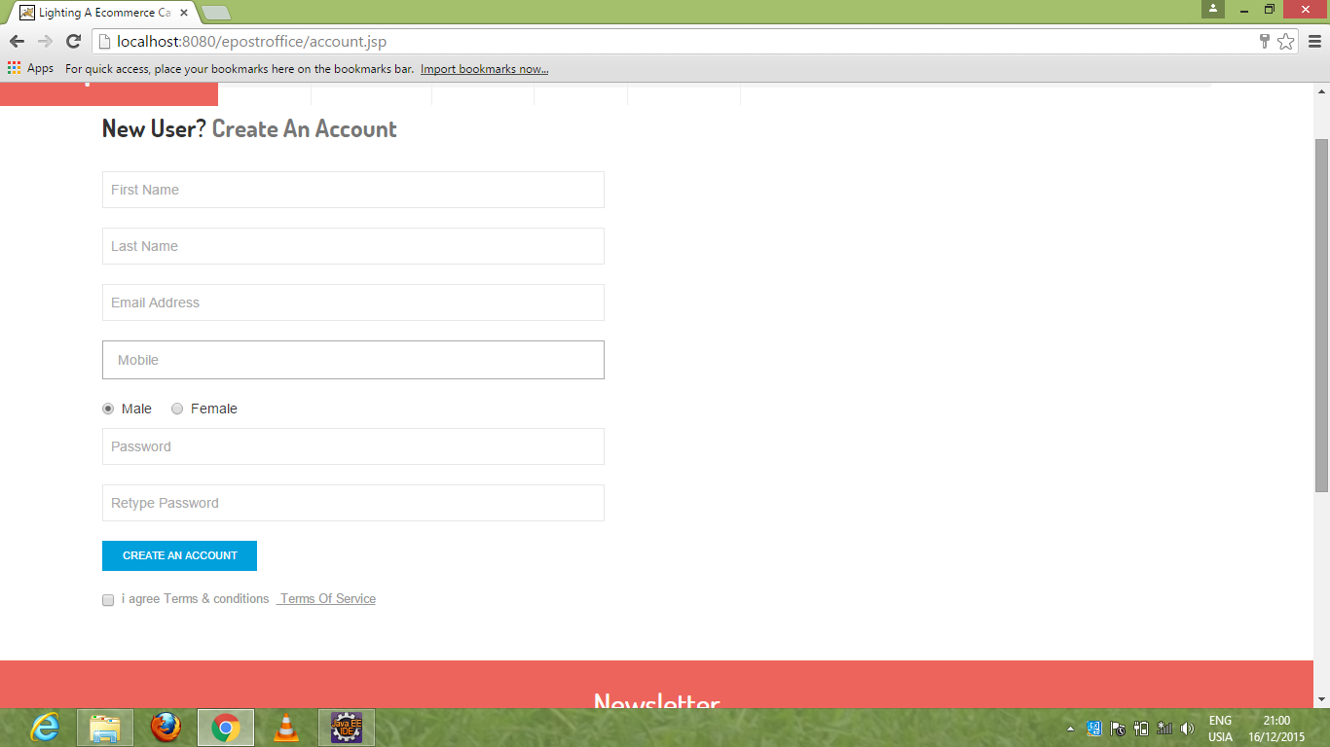 Snap 6.2 Registration Page

3) Login Page:

User can login by entering email address, password.

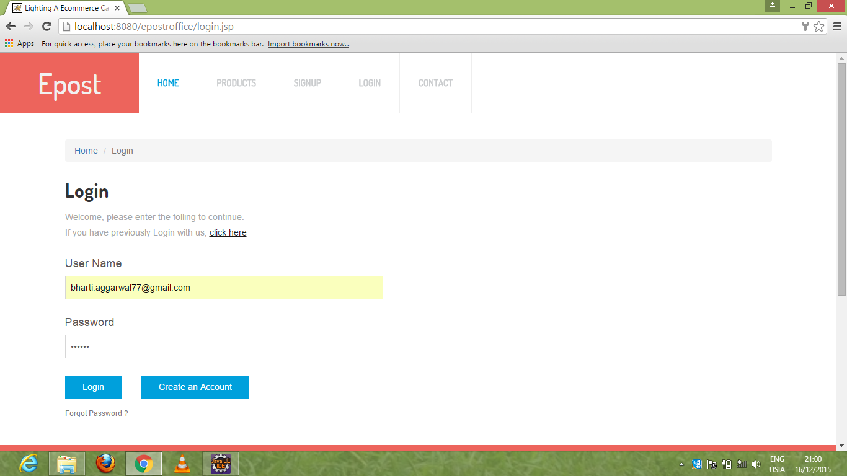

Snap 6.3 Login Page

4) Products:

It contain the images and detail of product which shown to user.

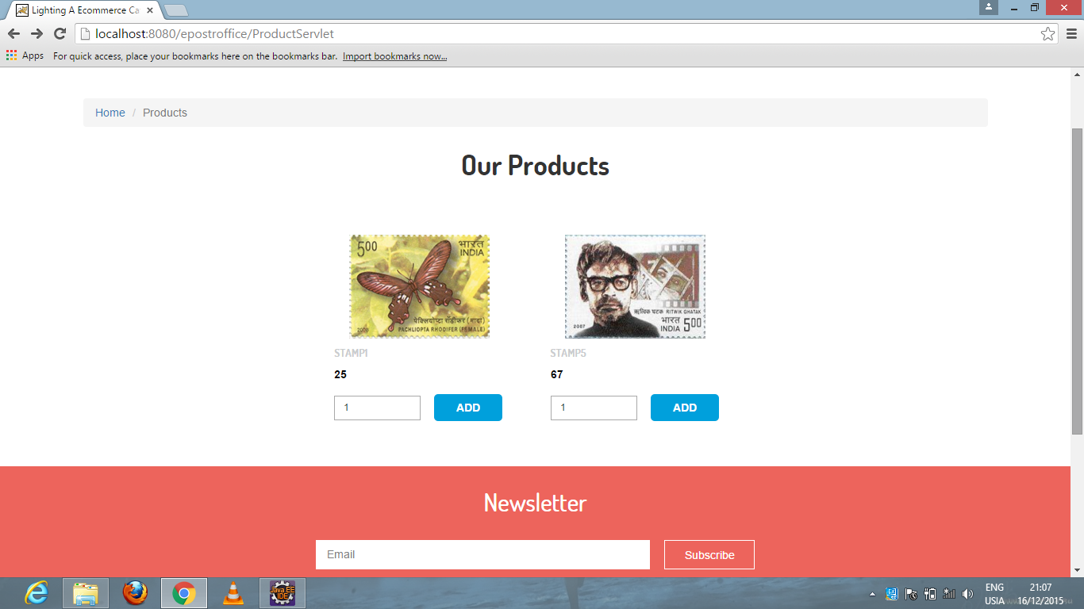 Snap 6.4 Product Page

5) Cart:

This will show the product added in the cart by user.

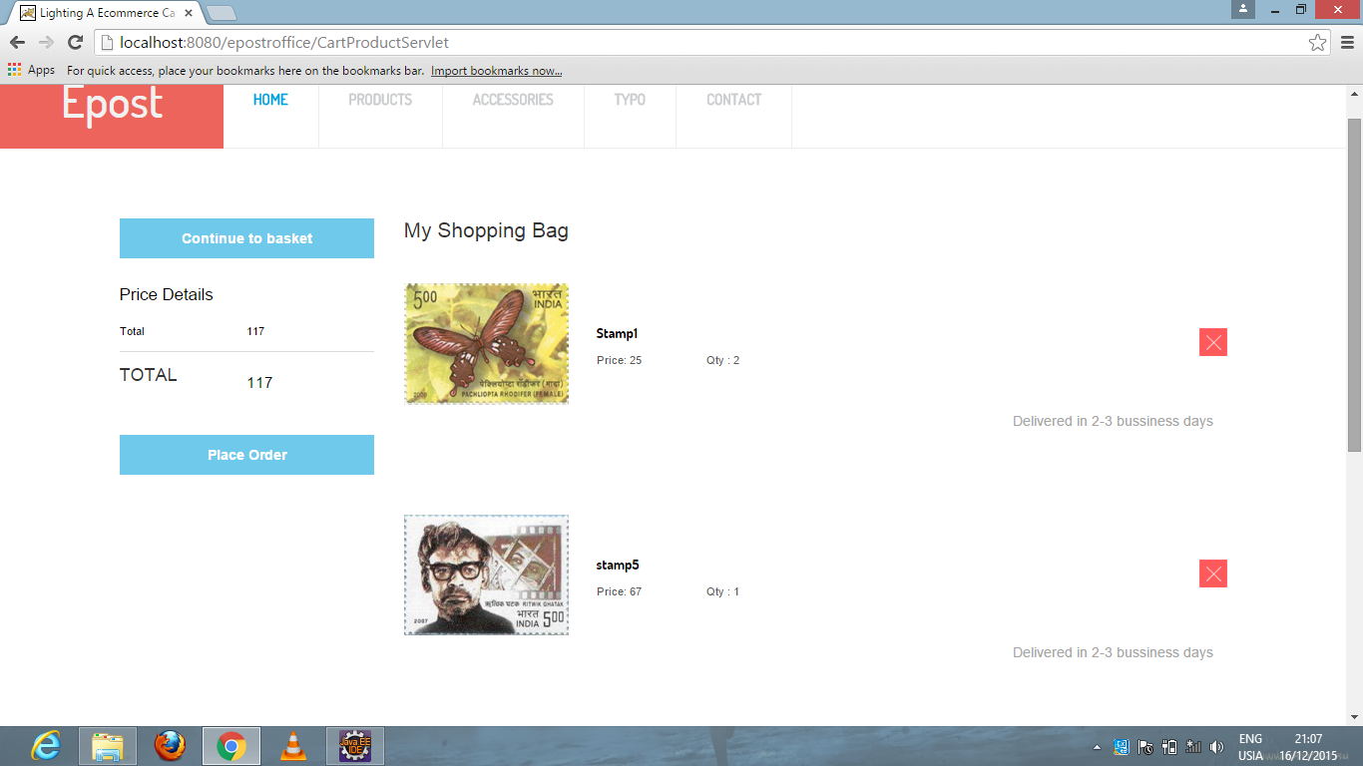

Snap 6.5 Cart Page

6) Delivery Details:

While delivering,user has to fill this filleds.

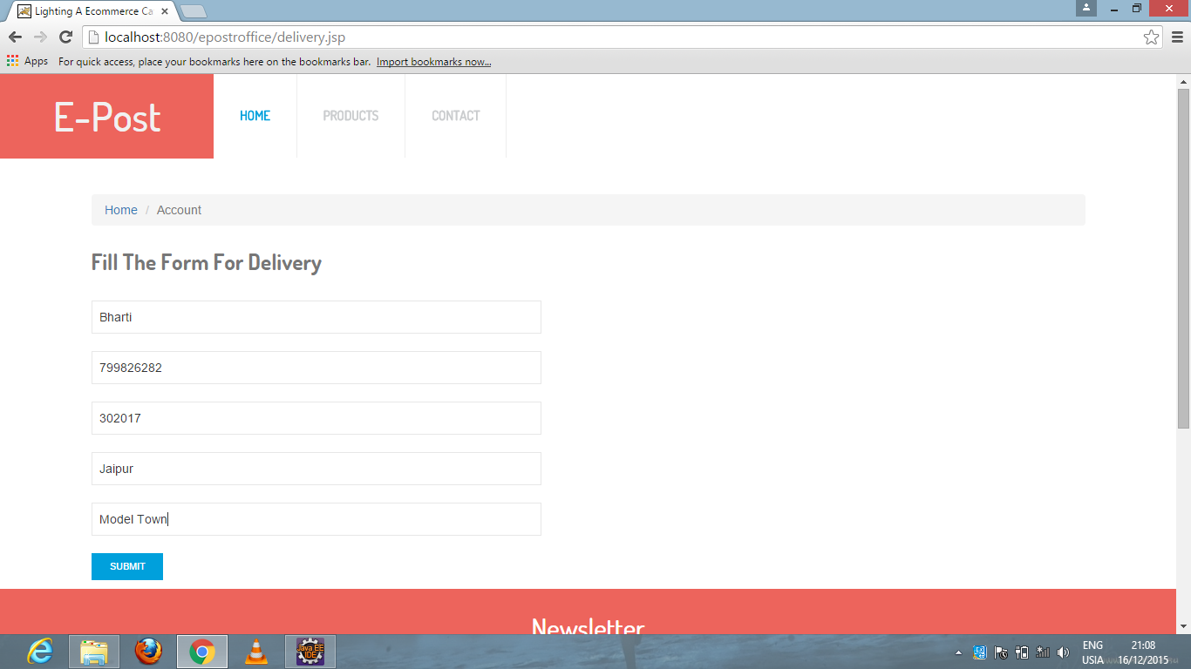

Snap 6.6 Delivery Page

7) After Submit:

After Submitting, this message will be displayed.

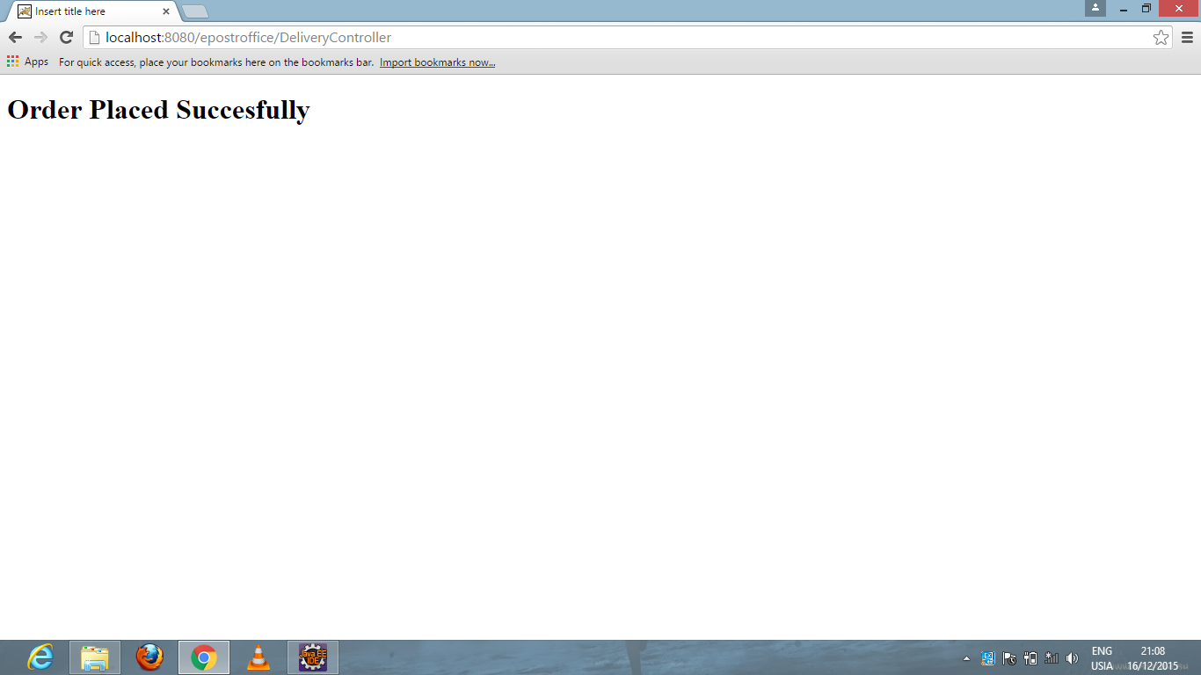

Snap 6.7 Message display

B) Admin Module:

1) Login Page:

Admin enter username and password for login.

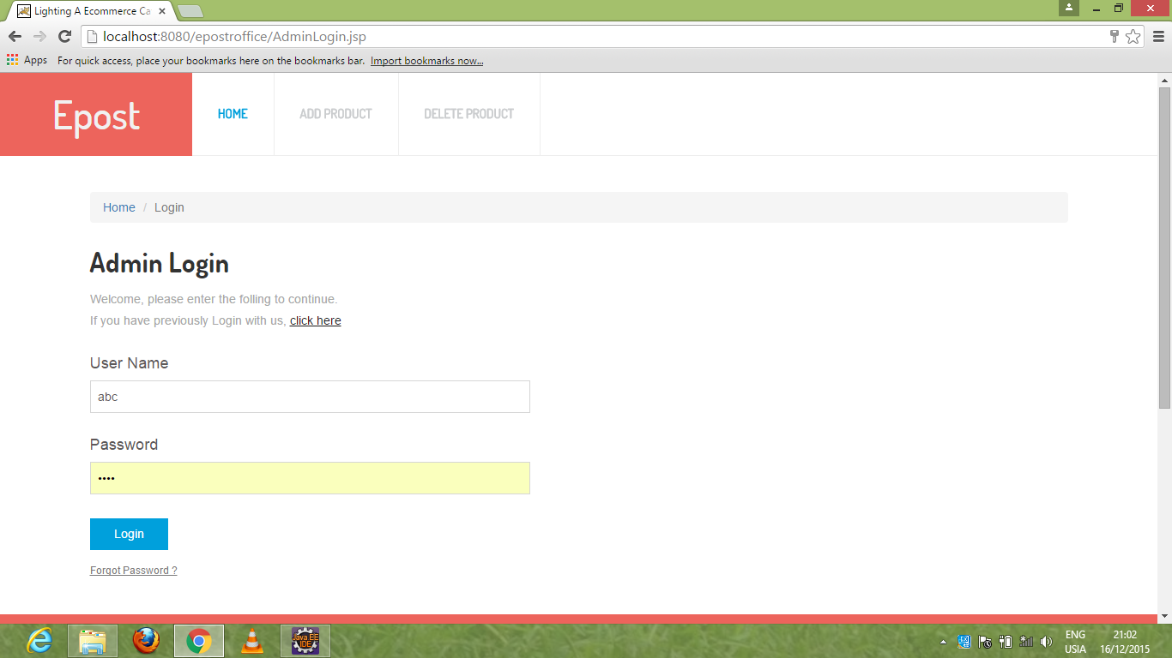

Snap 6.8 Login Page for Admin

2) Add Product Page:

Admin has to fill fields like product name, price, tag number, choose file.

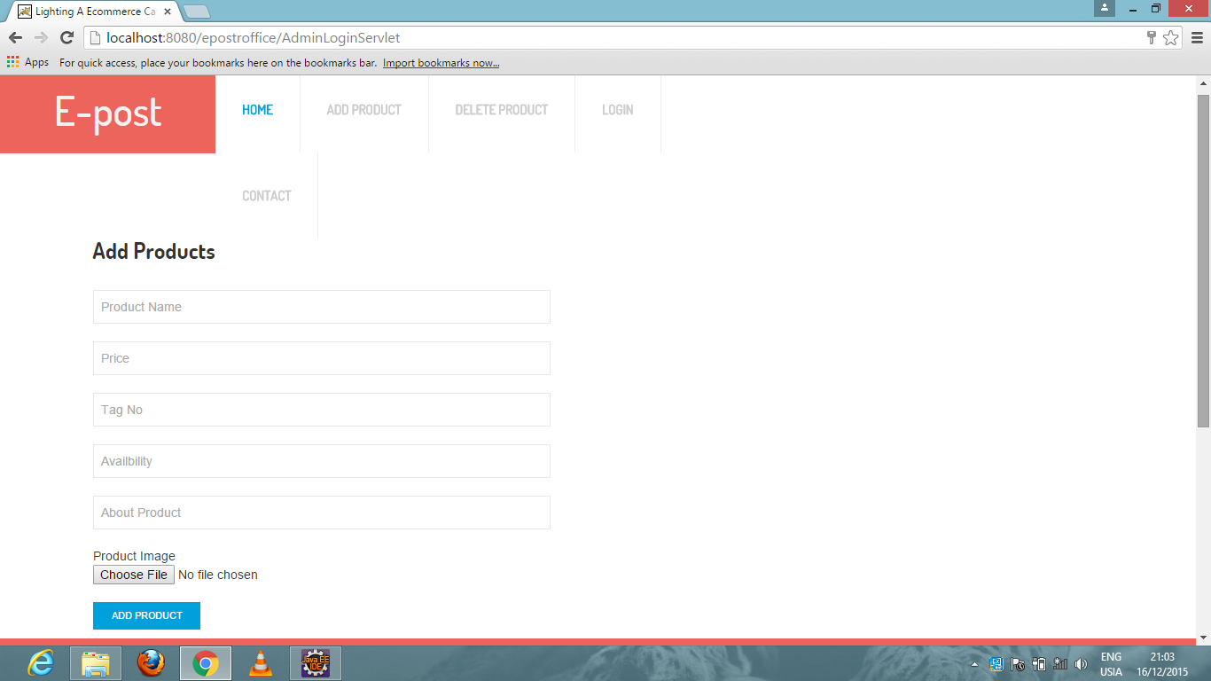

Snap 6.9 Add Product Page

3) Delete Product Page:

For deleting the product by click on delete button.

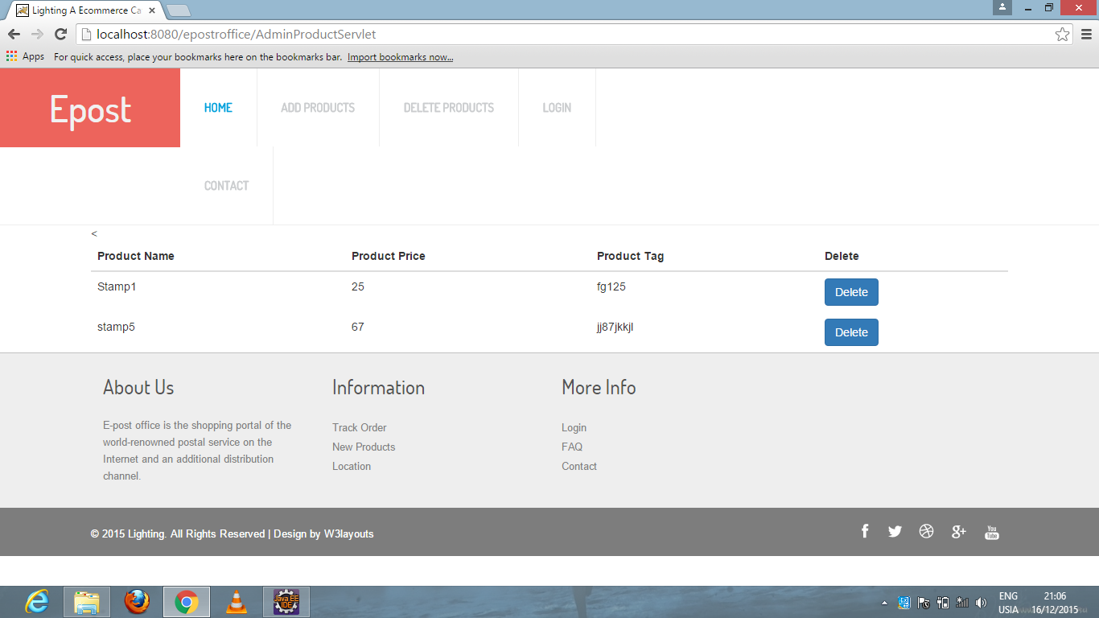

Snap 6.10 Delete Product Page

4) Product Page:

Product will be displayed.



Snap 6.11 Product Page

Chapter **–** 7

**SUPPLEMENTARY REQUIREMENTS**

**6.1. Software Requirement:**

* WINDOWS OS (XP / 2000 / 200 Server / 2003 Server)
* Visual Studio .Net 2005 Enterprise Edition
* Internet Information Server 5.0 (IIS)
* Visual Studio .Net Framework (Minimal for Deployment)
* SQL Server 2006 Enterprise Edition

**6.2. Hardware Requirement:**

* PIV2.8 GHz Processor and Above
* RAM 512MB and Above
* HDD 20 GB Hard Disk Space and Above

Chapter - 8

**LIST OF REFERENCES**

There are many references which are used in development of this document and proposed system. Some of them are as follows-

1. [www.indiapost.gov.in](http://www.indiapost.gov.in)

2. [www.codetutorial.com](http://www.codetutorial.com)

3. [www.jsptut.com](http://www.jsptut.com)

4. [www.w3school.com](http://www.w3school.com)

5. [www.google.co.in](http://www.google.co.in)

6. [www.postagestamps.gov.in](http://www.postagestamps.gov.in)

7. [www.csstutuorial.net](http://www.csstutuorial.net)

8. [www.echoecho.com](http://www.echoecho.com)

9. [www.tomcat.apache.org](http://www.tomcat.apache.org)

10. Silverschatz, Korth, Sudarshan - Database System Concepts,(2002)